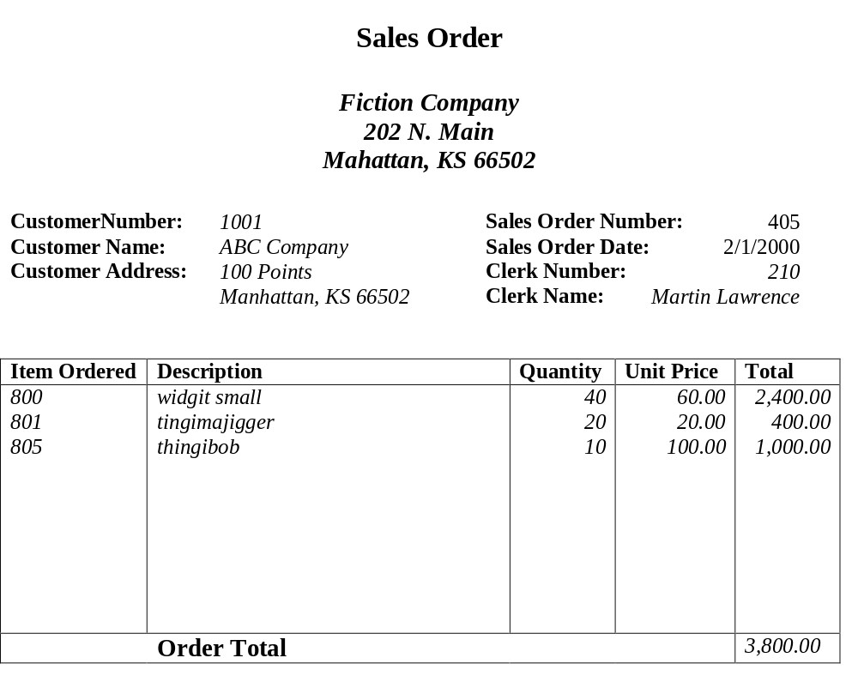
Example1:

Primary Key: Sales Order Number,

Example2:
